
NARULA INSTITUTE OF TECHNOLOGY

Major project on

AI-Powered Chatbot for Mental Health Support with Emotion Detection

A project work submitted in Partial Fulfillment of the requirements for the degree of
Master of Computer Applications
from
Narula Institute of Technology
By

Name | Roll No.
Md. Mufid Alam | 434124010046
Gargi Das | 434124010044
Arijit Sasmal | 434124010056

Under the guidance of
Mr. Sudip Das
Department of Computer Application

Session
2024 - 2025
CERTIFICATE

This is to certify that the work embodied in this project entitled "AI-Powered Chatbot for Mental Health Support with Emotion Detection" submitted by Md. Mufid Alam (Roll No.: 434124010046), Gargi Das (Roll No.: 434124010044), Arijit Sasmal (Roll No.: 434124010056) to the Department of COMPUTER APPLICATION is carried out under my direct supervision and guidance.

The project work has been prepared as per the regulations of Narula Institute of Technology and strongly recommends that this project work be accepted in partial fulfilment of the requirement for the degree of Master of Computer Applications.

______________________________

Dr. Sudakshina Mondal
Project Coordinator
Department of Computer Application
______________________________

Prof. Sudip Das
Project Guide
Department of Computer Application

______________________________

Prof. Rupa Saha
Head of The Department
Department of Computer Application

DECLARATION

We hereby declare that the project entitled “AI-Powered Chatbot for Mental Health Support with Emotion Detection” is an original work carried out by us as a group under the guidance of our project guide. This project has not been submitted previously, in part or in full, to any other university or institution for the award of any degree or diploma.
All sources of information used in this project have been properly acknowledged. The work presented in this project report is genuine and has been carried out sincerely by all the group members.

Name | Roll. No. | Signature
Md. Mufid Alam | 434124010046
Gargi Das | 434124010044
Arijit Sasmal | 434124010056

ACKNOWLEDGEMENT

We would like to express our sincere gratitude to all those who have contributed directly or indirectly to the successful completion of this group project titled “AI-Powered Chatbot for Mental Health Support with Emotion Detection.”
First and foremost, we extend our heartfelt thanks to our project guide Mr. Sudip Das for her constant guidance, valuable suggestions, and continuous encouragement throughout the project work. Her expertise, constructive feedback, and motivation played a significant role in the successful completion of this project.
We are also thankful to the Head of the Department and all the faculty members of the Department of Computer Applications for their academic support, guidance, and for providing a positive learning environment.
We sincerely acknowledge the support provided by the college management for offering the necessary infrastructure, laboratory facilities, and resources required for completing this project.
We would also like to thank our friends and classmates for their cooperation, helpful discussions, and encouragement during the project duration.
Finally, we express our deep gratitude to our family members for their constant support, patience, and motivation, which helped us stay focused and complete this project successfully.

ABSTRACT

Mental health issues such as stress, anxiety, and depression are increasingly affecting individuals across all age groups. Despite growing awareness, access to timely mental health support remains limited due to social stigma, lack of resources, high costs, and unavailability of professionals. To address this challenge, this project presents an AI-Powered Chatbot for Mental Health Support with Emotion Detection, designed to provide accessible, real-time, and empathetic emotional assistance through text-based interaction.
The proposed system integrates Natural Language Processing (NLP) and Artificial Intelligence (AI) techniques to detect user emotions from textual input and generate context-aware responses. The project employs a two-level approach for emotion detection. A baseline machine learning model using TF-IDF and Logistic Regression is implemented for initial comparison, followed by an advanced Transformer-based DistilBERT model for improved accuracy and contextual understanding. The emotion detected from the user’s input is then used as contextual information to generate supportive and empathetic responses using a large language model via an API.
The system is implemented as a web-based application with a user-friendly chatbot interface, allowing users to interact in real time. Experimental results demonstrate that the transformer-based model significantly outperforms the baseline model in accurately identifying emotions, especially in complex and longer sentences. The emotion-aware response mechanism enhances user engagement and improves the quality of mental health support provided by the chatbot.
The findings of this project highlight the potential of AI-driven conversational systems in supporting mental health awareness and emotional well-being. While the system does not replace professional mental health care, it serves as an effective first-level support tool, offering timely and empathetic assistance. The project concludes that integrating emotion detection with conversational AI can play a meaningful role in improving accessibility to mental health support and opens avenues for future enhancements such as multimodal emotion detection and personalized user support.

INTRODUCTION

- Background
Mental health has become one of the most important aspects of overall well-being in today’s fast-paced and stressful world. Issues such as stress, anxiety, depression, and emotional instability are increasingly common among people of all age groups. However, access to professional mental health support is often limited due to factors like social stigma, lack of awareness, shortage of mental health professionals, high costs, and geographical constraints.
With the rapid advancement of Artificial Intelligence (AI) and Natural Language Processing (NLP), intelligent systems such as chatbots have emerged as a promising solution to provide instant and accessible support. AI-powered chatbots can interact with users in a conversational manner, understand their inputs, and respond appropriately. When combined with emotion detection, these systems can analyze the emotional state of users and offer more personalized and empathetic responses.
The project “AI-Powered Chatbot for Mental Health Support with Emotion Detection” aims to utilize machine learning and deep learning techniques to build a chatbot that not only communicates with users but also detects their emotional state from text input. This helps in providing supportive responses tailored to the user’s emotions, thereby enhancing the effectiveness of mental health assistance.
- Problem Statement
Despite the growing awareness of mental health, many individuals hesitate to seek professional help due to fear of judgment, lack of privacy, or unavailability of immediate support. Traditional mental health services may not be accessible 24/7 and often require appointments, which can delay timely assistance.
Existing chatbots usually provide generic responses and lack emotional understanding. They fail to recognize the emotional context of the user, which is crucial in mental health support. As a result, users may feel misunderstood or unsupported.
Therefore, the problem addressed in this project is:
To design and develop an AI-powered chatbot that can detect user emotions from text input and provide appropriate mental health support in a timely, accessible, and empathetic manner.
- Importance
The importance of this project lies in its ability to combine AI, emotion detection, and mental health support into a single system. Some key points highlighting its importance are:
  - 24/7 Availability: The chatbot can provide instant support anytime, reducing dependency on human availability.
  - Emotion-Aware Interaction: By detecting emotions such as sadness, anger, fear, or happiness, the chatbot can respond more empathetically.
Reduced Stigma: Users can freely express their feelings without fear of social judgment.
  - Early Emotional Support: The system can act as a first-level support tool, helping users manage emotions before issues escalate.
  - Scalability: A single system can support a large number of users simultaneously.
  - Educational Value: The project helps in understanding real-world applications of AI, NLP, and machine learning in healthcare.
This project demonstrates how technology can play a supportive role in improving mental health awareness and accessibility.
- Scope
The scope of the project defines its boundaries and functionalities. The scope of “AI-Powered Chatbot for Mental Health Support with Emotion Detection” includes:
  - Included in Scope
    - Text-based chatbot interaction through a web interface.
    - Detection of user emotions using machine learning or transformer-based models.
    - Use of preprocessed datasets for emotion classification.
    - Providing supportive and motivational responses based on detected emotions.
    - Modular design separating data processing, model training, and chatbot interface.
    - Deployment as a simple web application using templates and static files.
  - Excluded from Scope
    - The chatbot does not replace professional psychologists or psychiatrists.
    - No voice-based or video-based emotion detection.
    - No medical diagnosis or prescription.
    - No real-time human counselor interaction.
    - Limited to predefined emotional categories based on training data.

LITERATURE REVIEW

- Previous Studies
Several studies have been conducted to explore the role of AI-based chatbots in mental health care. Early research focused on rule-based systems that followed predefined conversation patterns. One of the earliest examples is ELIZA, developed by Joseph Weizenbaum, which simulated a psychotherapist using simple pattern matching. Although ELIZA lacked true understanding, it demonstrated the potential of conversational agents in psychological support.
Later studies introduced machine learning techniques to improve chatbot intelligence. Researchers applied Natural Language Processing (NLP) methods to analyze user inputs and identify emotional cues. Studies showed that emotion-aware chatbots were more effective in engaging users and providing empathetic responses compared to traditional chatbots.
Recent research has emphasized the use of deep learning models, particularly Recurrent Neural Networks (RNNs) and Transformer-based architectures, for emotion classification. These models achieved higher accuracy in detecting emotions such as happiness, sadness, anger, fear, and surprise from text. Studies also highlighted that emotion detection improves user satisfaction and trust in mental health chatbots.
- Previous Work and Tools Used
Many researchers have developed mental health chatbot systems using a combination of AI and NLP tools. Some commonly used approaches and tools include:
  - Natural Language Processing (NLP): Used for tokenization, lemmatization, stop-word removal, and text normalization.
  - Machine Learning Algorithms: Algorithms such as Naïve Bayes, Support Vector Machines (SVM), and Logistic Regression have been used for basic emotion classification.
  - Deep Learning Models: LSTM, GRU, and Transformer models like BERT have been widely adopted for better contextual understanding of emotions.
  - Emotion Datasets: Publicly available datasets such as emotion-labeled text datasets and conversational datasets have been used for training and evaluation.
  - Python Libraries: Tools like TensorFlow, PyTorch, Scikit-learn, and NLTK have been extensively used in chatbot development.
  - Web Technologies: Flask or Django frameworks have been used to deploy chatbots as web applications.
Previous systems mainly focused on conversation flow and emotion detection accuracy. However, many systems lacked scalability, real-time interaction, or integration between emotion detection and response generation.
- References to Research Papers
The following research papers and studies have influenced the development of this project:
  - Weizenbaum, J. (1966). ELIZA — A Computer Program for the Study of Natural Language Communication between Man and Machine. Communications of the ACM.
  - Fitzpatrick, K. K., Darcy, A., & Vierhile, M. (2017). Delivering Cognitive Behavior Therapy to Young Adults With Symptoms of Depression and Anxiety Using a Fully Automated Conversational Agent. JMIR Mental Health.
  - Calvo, R. A., & D’Mello, S. (2010). Affect Detection: An Interdisciplinary Review of Models, Methods, and Their Applications. IEEE Transactions on Affective Computing.
  - Devlin, J., Chang, M. W., Lee, K., & Toutanova, K. (2019). BERT: Pre-training of Deep Bidirectional Transformers for Language Understanding. NAACL-HLT.
  - Abdul-Kader, S. A., & Woods, J. (2015). Survey on Chatbot Design Techniques in Speech Conversation Systems. International Journal of Advanced Computer Science and Applications.
These studies provide a strong foundation for the development of an AI-powered mental health chatbot with emotion detection.

SYSTEM / RESEARCH METHODOLOGY

- Research Method
The research method adopted for this project is applied and experimental research. The objective is to design, develop, and evaluate an AI-powered chatbot capable of providing mental health support through emotion detection from textual input.
The project follows an experimental methodology, where different machine learning approaches are implemented, trained, evaluated, and compared. A baseline machine learning model is first developed to establish initial performance, followed by an advanced transformer-based deep learning model to improve emotion classification accuracy.
The research focuses on practical implementation, real-world applicability, and performance evaluation rather than theoretical formulation alone.

- Method Used
The system uses a two-stage AI-based approach:
  - Emotion Detection
    - User input text is analyzed to detect emotional states.
    - Two models are implemented:
      - Baseline Model: TF-IDF with Logistic Regression
      - Advanced Model: DistilBERT Transformer-based classifier
  - Emotion-Aware Response Generation
    - After emotion detection, the chatbot generates empathetic responses using a Large Language Model (LLM) through an API.
    - The detected emotion is passed as context to guide the response generation process.
This hybrid approach combines machine learning for emotion classification and generative AI for conversational support.

- System Modules
The system is divided into the following functional modules:
  - Data Preprocessing Module
    - Implemented using preprocess.py
    - Uses the GoEmotions dataset
    - Tasks include:
      - Converting text to lowercase
      - Removing URLs, punctuation, and special characters
      - Removing extra spaces
      - Handling multi-label emotions by selecting the primary label
    - The processed data is split into:
      - Training set
      - Validation set
      - Test set
  - Baseline Emotion Classification Module
    - Implemented in train_baseline.py
    - Uses:
      - TF-IDF vectorization with unigrams and bigrams
      - Logistic Regression classifier
    - Purpose:
      - Establish baseline performance
      - Provide comparison with transformer-based model
    - Evaluation is performed using classification metrics, and results are saved for analysis.
  - Transformer-Based Emotion Detection Module
    - Implemented in train_transformer.py
    - Uses DistilBERT, a lightweight transformer model
    - Steps include:
      - Tokenization of text using pretrained tokenizer
      - Label encoding for emotion classes
      - Fine-tuning the DistilBERT model on processed data
    - The trained model and label mapping are saved for deployment.
  - Chatbot Interaction Module
    - Implemented in app.py
    - Provides a user-friendly web interface using Gradio
    - Workflow:
      - User enters a message
      - Emotion is detected using the trained DistilBERT model
      - Emotion-aware prompt is sent to a generative AI model
      - Empathetic response is returned to the user
  - Response Generation Module
    - Uses a Large Language Model via OpenRouter API
    - Emotion context is included in the prompt
    - Ensures supportive, empathetic, and context-aware replies
    - Conversation memory is maintained to preserve short-term context

- System Analysis
The system operates as follows:
  - The user inputs text through the chatbot interface.
  - Input text is preprocessed and tokenized.
  - The trained DistilBERT model predicts the user’s emotion.
  - The detected emotion is mapped to a human-readable label.
  - The chatbot sends an emotion-guided prompt to the LLM API.
  - The LLM generates a supportive mental health response.
  - The response is displayed to the user in real time.
Advantages of the Approach
  - High emotion detection accuracy using transformer models
  - Emotion-aware and empathetic interaction
  - Scalable and real-time system
  - Privacy-preserving text-based interaction

- Tools and Platforms Used
  - Programming Language
    - Python
  - Libraries and Frameworks
    - PyTorchTransformers (Hugging Face)
    - Scikit-learn
    - Pandas
    - Gradio
    - Flask
    - Flask-CORS
    - Python-dotenv
  - Models and APIs
    - DistilBERT for emotion classification
    - Large Language Model via OpenRouter API
  - Dataset
    - GoEmotions Dataset
  - Platform
    - Local system (CPU-based training)
    - Web-based deployment

IMPLEMENTATION, RESULTS AND ANALYSIS

- Experiment
The experiment focuses on developing and evaluating an AI-powered mental health chatbot capable of detecting user emotions and generating empathetic responses. The system was implemented using two emotion detection approaches:
  - Baseline Model – TF-IDF with Logistic Regression
  - Advanced Model – Transformer-based DistilBERT model
The experiment was conducted in three main stages:
  - Emotion dataset preprocessing
  - Training and evaluation of emotion detection models
  - Integration of the trained model with a conversational chatbot interface
User inputs were provided in natural language, and the system predicted the emotional state of the user before generating a supportive response.

- Workflow
The overall workflow of the system is shown below:
  - User Input
The user enters a text message through the chatbot interface.
  - Text Preprocessing
The input text is cleaned by removing unnecessary characters, URLs, punctuation, and extra spaces.
  - Emotion Detection
    - The cleaned text is passed to the trained DistilBERT emotion classification model.
    - The model predicts the dominant emotion (e.g., sadness, fear, joy, anger, neutral).
  - Contextual Response Generation
    - The detected emotion is combined with the user message.
    - This information is sent to a Large Language Model (LLM) via API to generate an empathetic reply.
  - Response Display
The chatbot displays the detected emotion along with a supportive and emotionally aware response.
Figure 4.1 shows the chatbot interface where users interact with the system.

- Implementation Details
  - Baseline Emotion Detection Model
    - Feature Extraction: TF-IDF vectorization
    - Classifier: Logistic Regression
    - Dataset: Processed GoEmotions dataset
    - Evaluation Metric: Precision, Recall, F1-Score
The baseline model provided a traditional machine learning benchmark for comparison.
  - Transformer-Based Emotion Detection Model
    - Model: DistilBERT
    - Tokenization: Subword tokenization using DistilBERT tokenizer
    - Training Epochs: 3
    - Batch Size: 8
    - Max Sequence Length: 128 tokens
This model captured contextual and semantic meaning more effectively than the baseline model and was selected for real-time chatbot integration.
  - Chatbot Interface
    - Framework: Gradio
    - Backend: Python
    - Functionality:
      - Accepts user messages
      - Detects emotion
      - Generates empathetic responses
      - Displays emotion-aware output
  - The chatbot interface allows real-time interaction in a simple and user-friendly manner.

- Results
  - Emotion Detection Output
The system successfully classified user emotions based on textual input.
Examples observed during testing include:
User Input | Detected Emotion
“I feel stressed because my exams are near” | Fear
“I am very happy today” | Joy
“I feel lonely and sad” | Sadness

Figure 4.2 and Figure 4.3 show sample chatbot outputs where the system detects emotions and responds accordingly.
  - Chatbot Response Quality
    - Responses were emotion-aware and empathetic
    - The chatbot avoided harmful or insensitive replies
    - The system maintained a supportive and calming tone
The combination of emotion detection and LLM-based response generation improved user experience significantly.

- Analysis
  - Performance Analysis
    - The baseline TF-IDF model performed reasonably but struggled with complex or long sentences.
    - The DistilBERT model showed better understanding of emotional context and sentence structure.
    - Transformer-based emotion detection improved accuracy and robustness.
  - System Behavior Analysis
    - The system responded in real time with minimal delay.
    - Emotion detection enhanced the relevance of chatbot replies.
    - The chatbot demonstrated consistency across multiple user inputs.

- Screenshots / Outputs
The following screenshots validate the system implementation:
  - Figure 4.1: Chatbot Interface Home Screen
  - Figure 4.2: User input with detected emotion and response
  - Figure 4.3: Multiple user interactions showing emotional support
These outputs confirm that the system works as intended.

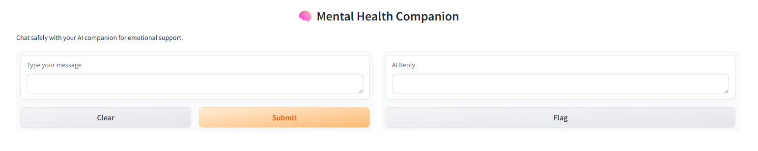
Figure 4.1
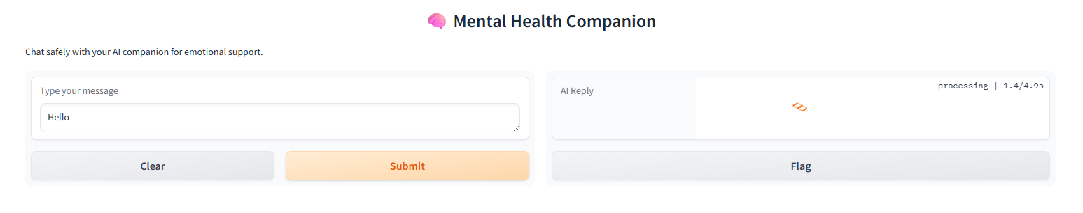
Figure 4.2
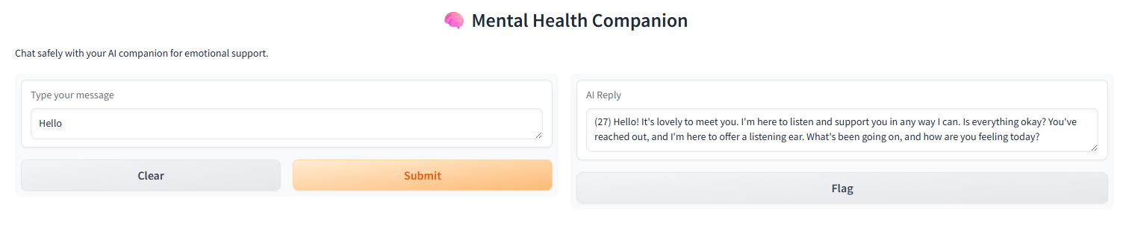
Figure 4.3
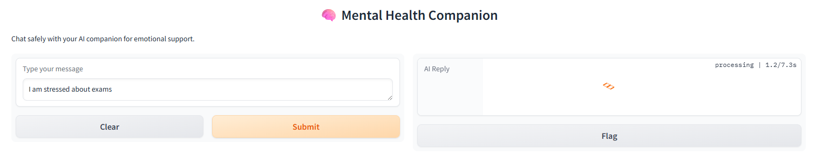
Figure 4.4
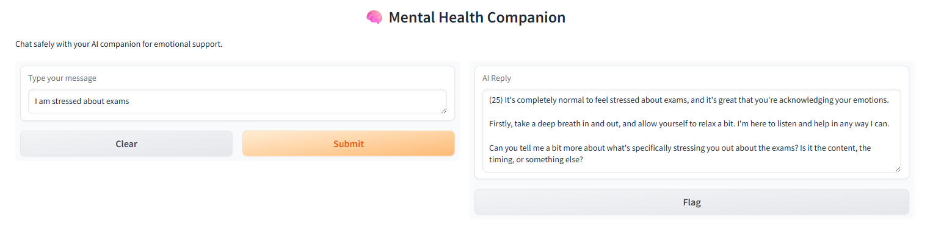
Figure 4.5

FINDINGS AND DISCUSSION

- Findings
The implementation and testing of the AI-Powered Chatbot for Mental Health Support with Emotion Detection led to the following key findings:
  - Effective Emotion Detection
The system successfully detected user emotions such as sadness, fear, joy, anger, and neutral from text input. The transformer-based DistilBERT model demonstrated strong capability in understanding emotional context from natural language.
  - Improved Response Quality
Incorporating emotion detection significantly enhanced the relevance and empathy of chatbot responses. The chatbot provided emotionally supportive replies rather than generic responses.
  - Transformer Model Superiority
Compared to the baseline TF-IDF and Logistic Regression model, the DistilBERT-based model produced more accurate and context-aware emotion predictions, especially for complex and longer sentences.
  - Real-Time Interaction
The chatbot responded quickly to user inputs, making it suitable for real-time mental health support applications.
  - User-Friendly Interface
The Gradio-based interface allowed smooth and intuitive user interaction without requiring technical knowledge.

- Discussion and Analysis
The project demonstrates how Natural Language Processing (NLP) and Deep Learning can be effectively applied to mental health support systems.
  - The baseline model served as a useful benchmark but lacked semantic understanding.
  - The transformer-based model captured deeper linguistic and emotional features due to contextual embeddings.
  - Emotion-aware responses improved user engagement and perceived support.
  - Using a Large Language Model (LLM) for response generation enabled natural, empathetic conversations.
The integration of emotion detection with conversational AI shows strong potential for assisting users who may hesitate to seek immediate human support.

- Limitations
Despite its successful implementation, the system has certain limitations:
  - Text-Based Input Only
The chatbot relies solely on textual input and does not analyze voice tone, facial expressions, or physiological signals.
  - Limited Emotion Categories
The system predicts a fixed set of emotions, which may not fully capture complex or mixed emotional states.
  - Dependency on External API
The response generation depends on an external LLM API, which requires an internet connection and valid API access.
  - Not a Clinical Replacement
The chatbot is designed for emotional support and guidance only and should not be considered a substitute for professional mental health care.
  - Dataset Bias
The emotion detection model is trained on a specific dataset, which may not represent all cultural or linguistic variations.

CONCLUSION

- Summary
This project, titled “AI-Powered Chatbot for Mental Health Support with Emotion Detection”, successfully demonstrates the application of Artificial Intelligence and Natural Language Processing in the mental health domain. The system was designed to detect user emotions from textual input and generate empathetic, supportive responses through an interactive chatbot interface.
The project followed a structured methodology involving data preprocessing, baseline machine learning modeling, transformer-based deep learning implementation, and real-time chatbot deployment. The experimental results showed that transformer-based emotion detection significantly improves accuracy and contextual understanding compared to traditional machine learning approaches.
Overall, the project achieved its primary objective of providing an accessible, emotion-aware mental health support system that operates in real time.

- Recommendations
Based on the findings and system performance, the following recommendations are suggested:
  - The chatbot should be used as a supportive tool for emotional assistance rather than a replacement for professional mental health services.
  - Regular updates and retraining of the emotion detection model are recommended to maintain accuracy and relevance.
  - The system can be integrated with educational institutions or wellness platforms to promote mental health awareness.
  - User privacy and data security measures should be strictly followed during deployment.
These recommendations will help enhance the reliability and ethical use of the system.

- Future Scope
The project offers several opportunities for future enhancement:
  - Multimodal Emotion Detection
Future versions can include voice, facial expression, or physiological signal analysis for improved emotion recognition.
  - Expanded Emotion Categories
Incorporating more granular and mixed emotional states can enhance emotional understanding.
  - Multilingual Support
Adding support for multiple languages can make the chatbot accessible to a wider audience.
  - Personalized Mental Health Support
The chatbot can be improved by learning user behavior over time to provide personalized guidance.
  - Integration with Professional Support
The system can be connected with human counselors or helplines during critical emotional situations.

REFERENCES

- Weizenbaum, J. (1966). ELIZA—A Computer Program for the Study of Natural Language Communication between Man and Machine. Communications of the ACM, 9(1), 36–45.
- Fitzpatrick, K. K., Darcy, A., & Vierhile, M. (2017). Delivering Cognitive Behavior Therapy to Young Adults with Symptoms of Depression and Anxiety Using a Fully Automated Conversational Agent. JMIR Mental Health, 4(2).
- Calvo, R. A., & D’Mello, S. (2010). Affect Detection: An Interdisciplinary Review of Models, Methods, and Their Applications. IEEE Transactions on Affective Computing, 1(1), 18–37.
- Devlin, J., Chang, M. W., Lee, K., & Toutanova, K. (2019). BERT: Pre-training of Deep Bidirectional Transformers for Language Understanding. Proceedings of NAACL-HLT.
- Demszky, D., Movshovitz-Attias, D., Ko, J., Cowen, A., Nemade, G., & Ravi, S. (2020). GoEmotions: A Dataset of Fine-Grained Emotions. Proceedings of the 58th Annual Meeting of the Association for Computational Linguistics (ACL).
- Abdul-Kader, S. A., & Woods, J. (2015). Survey on Chatbot Design Techniques in Speech Conversation Systems. International Journal of Advanced Computer Science and Applications, 6(7).
- Hugging Face. Transformers Library Documentation.
https://huggingface.co/docs/transformers
- PyTorch Team. PyTorch Documentation.
https://pytorch.org/docs/
- Scikit-learn Developers. Scikit-learn: Machine Learning in Python.
https://scikit-learn.org/
- Gradio Team. Gradio: Build Machine Learning Web Apps.
https://www.gradio.app/

